Given the root of a binary tree, find the maximum value V for which there exists **different** nodes A and B where V = |A.val - B.val| and A is an ancestor of B.

(A node A is an ancestor of B if either: any child of A is equal to B, or any child of A is an ancestor of B.)

**Example 1:**

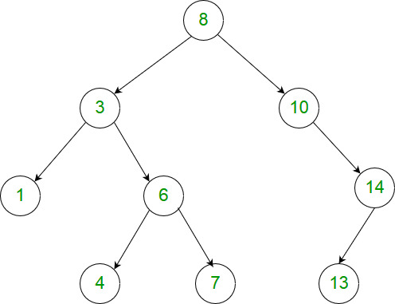

**Input:** [8,3,10,1,6,null,14,null,null,4,7,13]

**Output:** 7

**Explanation:**

We have various ancestor-node differences, some of which are given below :

|8 - 3| = 5

|3 - 7| = 4

|8 - 1| = 7

|10 - 13| = 3

Among all possible differences, the maximum value of 7 is obtained by |8 - 1| = 7.

**Note:**

1. The number of nodes in the tree is between 2 and 5000.
2. Each node will have value between 0 and 100000.